***FitFlex:Your Personal Fitness Companion.***

***Team ID: NM2025TMID40206***

***Team Leader: Dannya K***

***Team member: Aarthy S***

***Team member: Karthiga M***

***Team member: Sathya S***

***PROJECT OBJECTIVE***

***The objective of this project is to develop a comprehensive fitness platform that promotes health, wellness, and active living. It aims to provide users with personalized workout plans, nutrition guidance, and progress tracking to help them achieve their fitness goals. The system will focus on accessibility, motivation, and performance monitoring through features such as exercise tutorials, diet recommendations, goal setting, and real-time progress analysis. By integrating user-friendly technology and evidence-based fitness practices, the project seeks to encourage consistent physical activity, improve overall well-being, and create a supportive environment for individuals at all fitness levels.***

***SETUP INSTRUCTIONS***

***Install Node.js and npm on your development machine, as they are required to run***

***JavaScript on the server-side.***

Download: https://nodejs.org/en/download/

Installation instructions: <https://nodejs.org/en/download/package-manager/>

After downloading open window as administrator

*Type set-executive policy unrestricted and press enter*

*And in the next step type Y and press enter*

***STEPS TO DOWNLOAD AND EXECUTED PROJECT***

*From smartinternz portal you can find Project flow and now there will be two links one is demo video and other is code drive link*

*Click on the code drive and extract code and go to vs window and type cd code*

*And now type npm instal lit will take while to install*

*After installed you have to type npm start to start project*

*Now your application will be opened in your browser with https:// localhost:3000*

***PROJECT STRUCTURE***

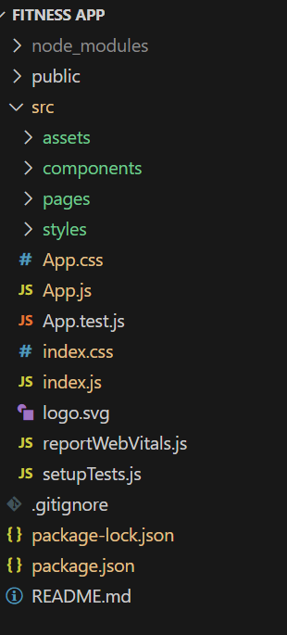 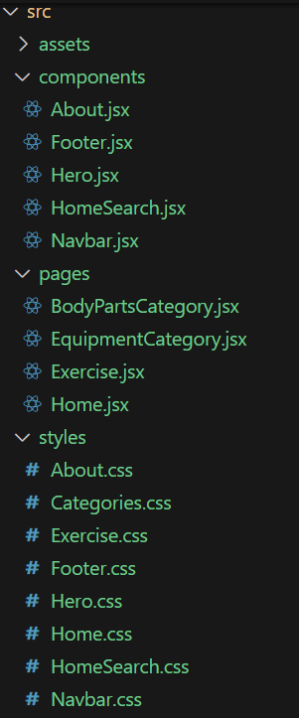

*Running the application*

*Component document*

*In this project we have four major parts there are context, page style and components*

***Style***

*CSS frameworks/libraries: describe any CSS frameworks*

*Libraries or pre – processors*

***DEMO LINK***

*Before starting to work on this project, let’s see the demo.*

*Demo link:* [*https://drive.google.com/file/d/1dVVEwbZgAltQyv8yXszbQkw98dhnOb9V/view?usp=sharing*](https://drive.google.com/file/d/1dVVEwbZgAltQyv8yXszbQkw98dhnOb9V/view?usp=sharing)

*Use the code in:*

[*https://drive.google.com/drive/folders/14f9eBQ5W7VrLdPhP2W6PzOU_HCy8UMex?usp=sharing*](https://drive.google.com/drive/folders/14f9eBQ5W7VrLdPhP2W6PzOU_HCy8UMex?usp=sharing)

***Pre - Requisite:***

* *Download* ***Node.js LTS version*** *from* [*https://nodejs.org/en/download/*](https://nodejs.org/en/download/)

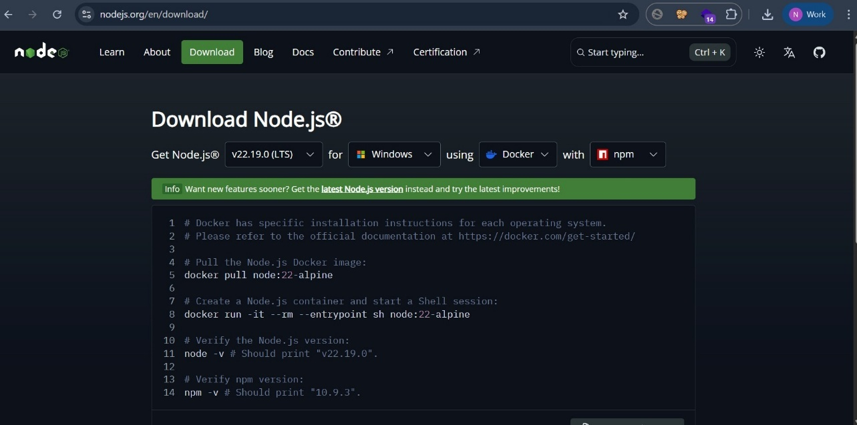

* *Select your system configuration and click on*

*○* ***Windows installer (.msi)*** *if windows*

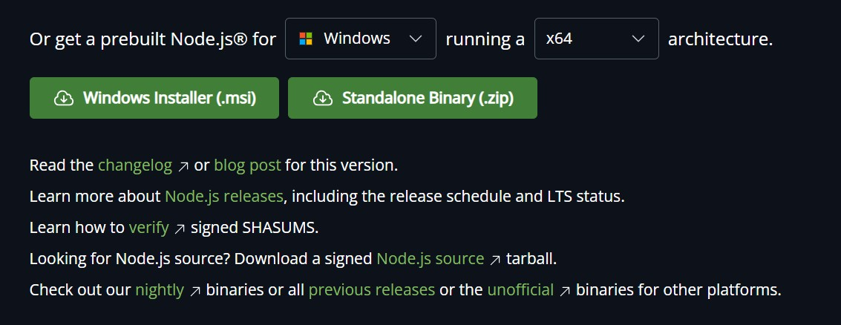

***Or***

*○* ***macOS installer (.pkg)*** *if macOS*

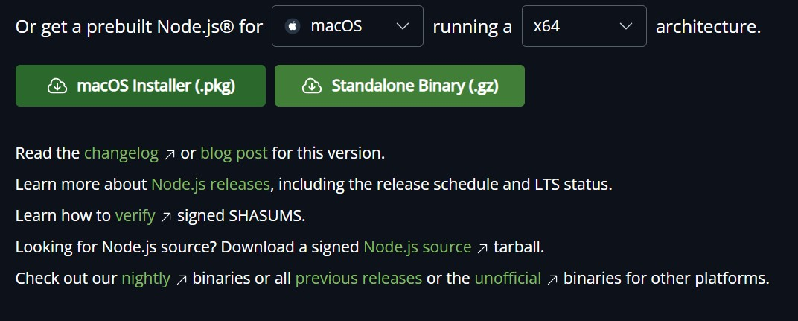

* *After downloading, install Node.js by opening the downloaded file and follow the instructions below.*

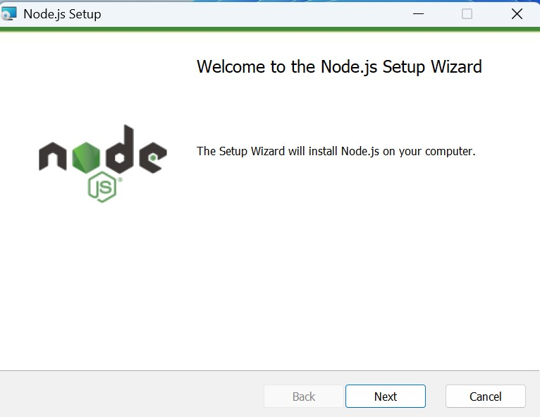

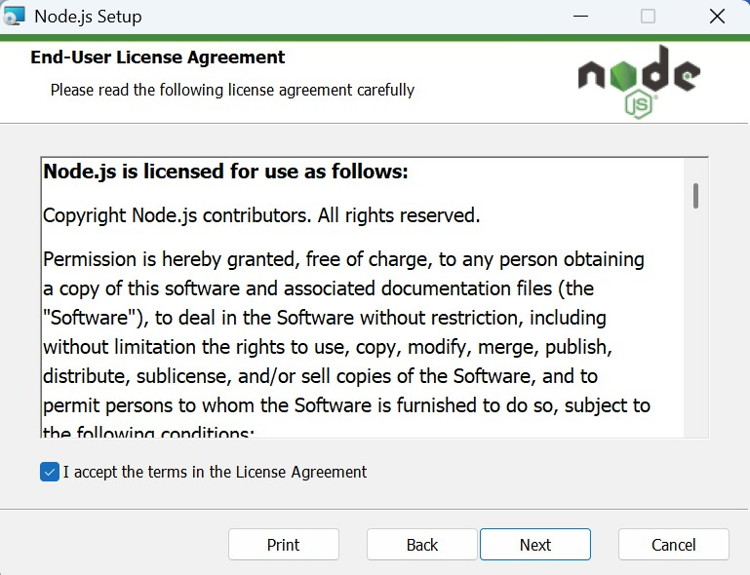

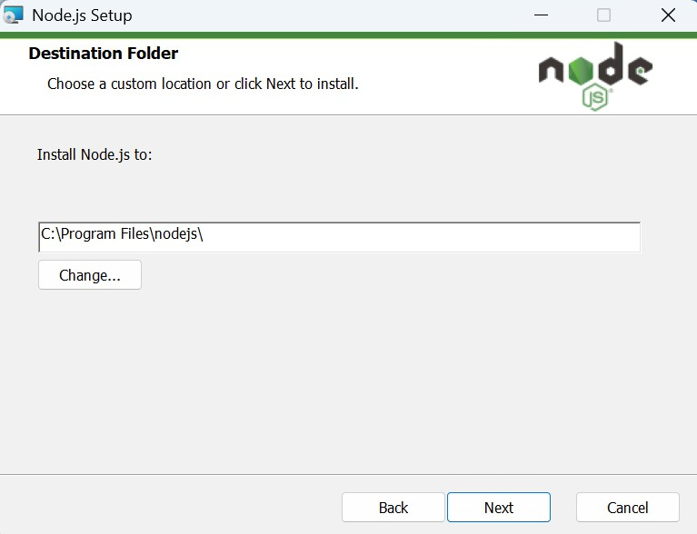

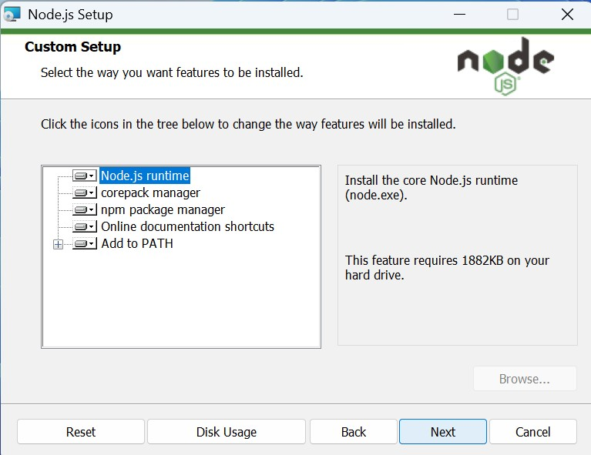

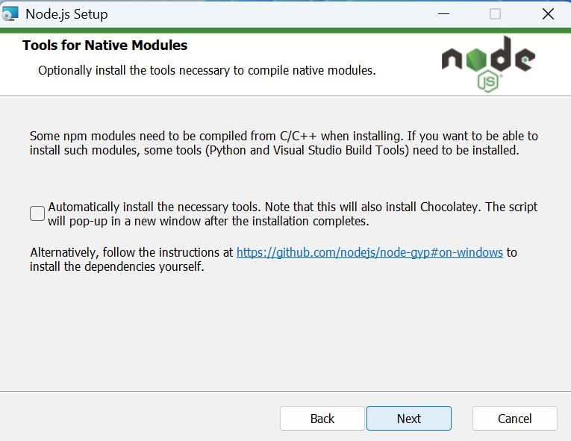

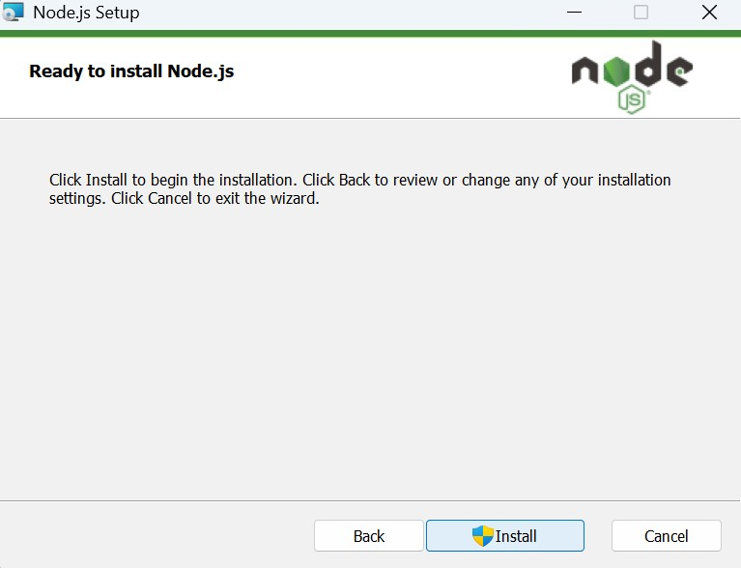

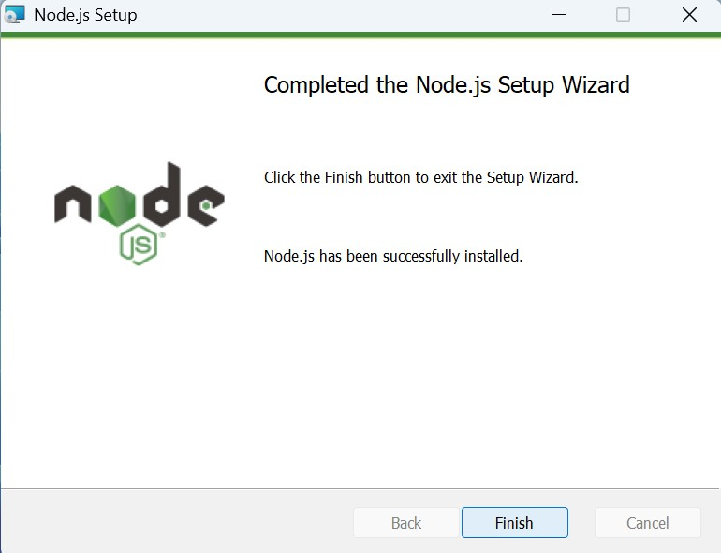

* *After installing Node.js, open* ***Windows PowerShell As Administrator***

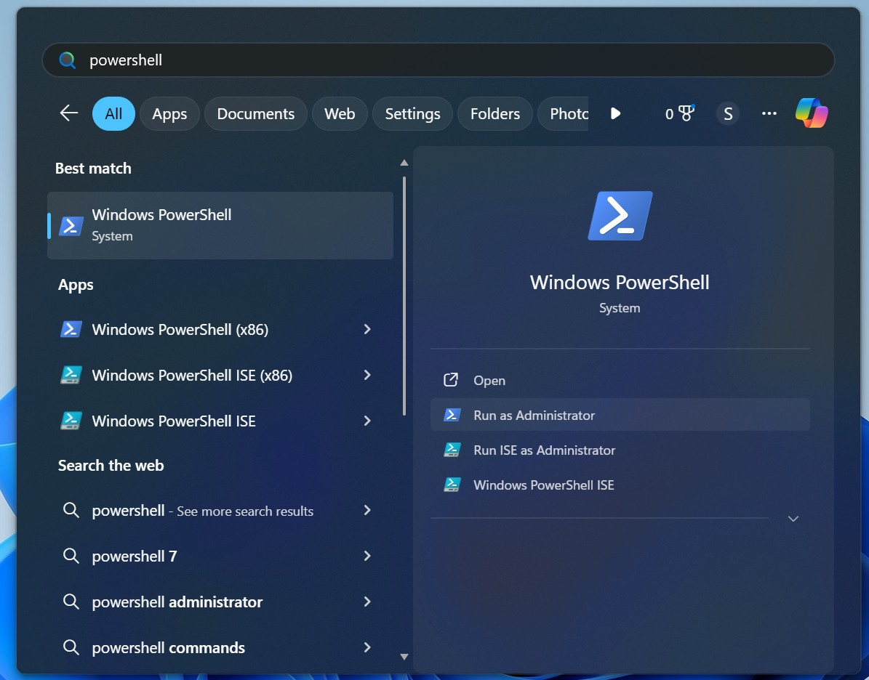

* *Type* ***set-executionPolicy unrestricted*** *and press enter*

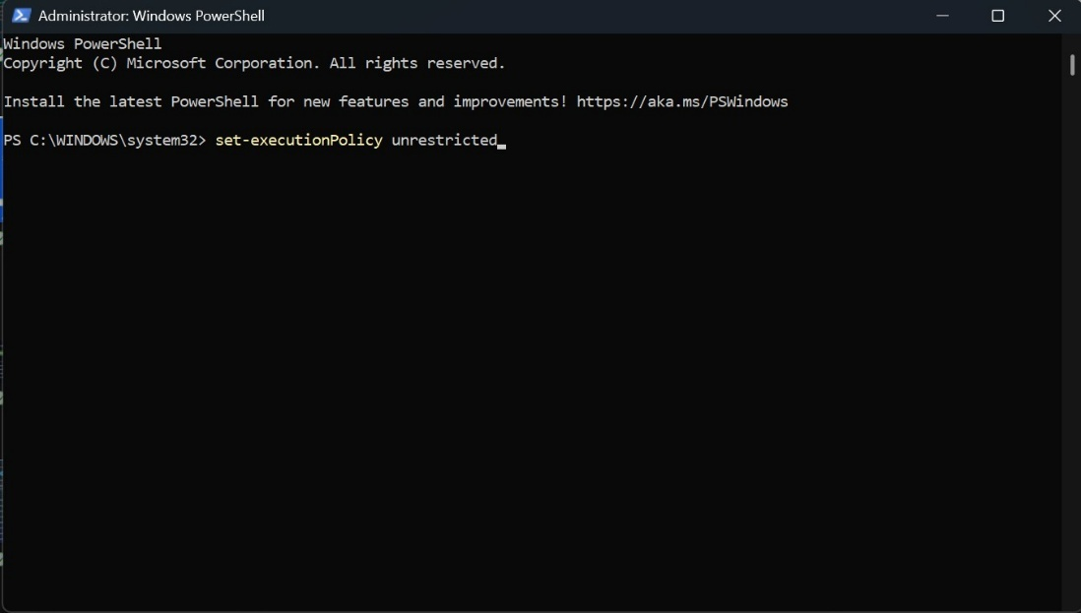

* *In the next step type* ***Y*** *and press enter*

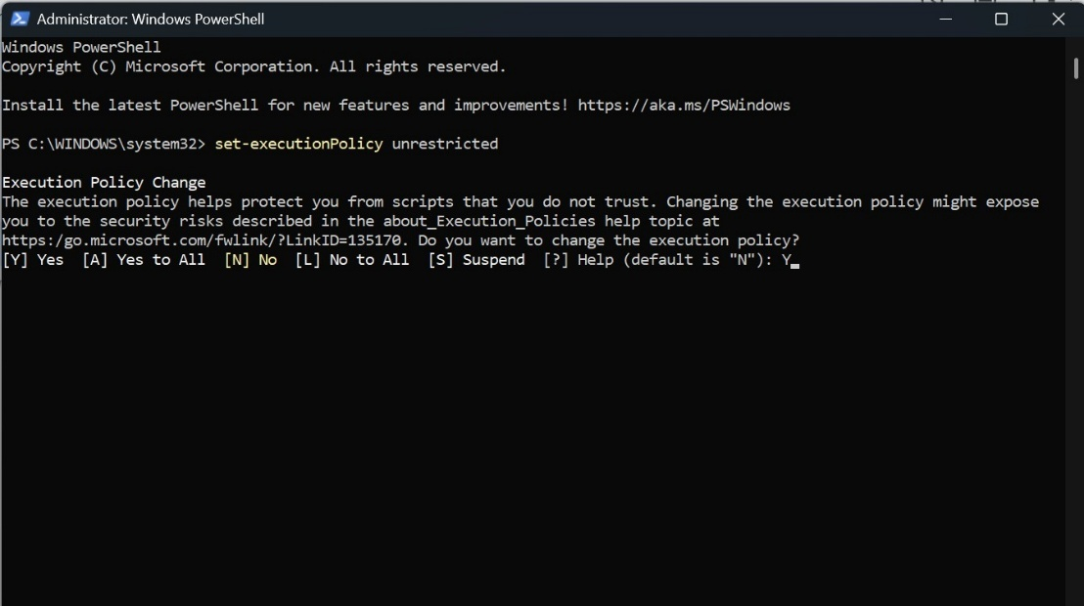

***Steps To Download And Execute Project:***

* *From your SmartInternz portal GoTo Projects → Access Resources*

*→ Guided Projects → Go To Workspace*

*●*

* *Inside Guided Project you can find* ***Project Flow***
* *Now you can see two links one is the* ***demo video*** *and the other is the* ***code drive*** *link.*
* *Click on the code drive link or copy paste that link in your new chrome tab.*

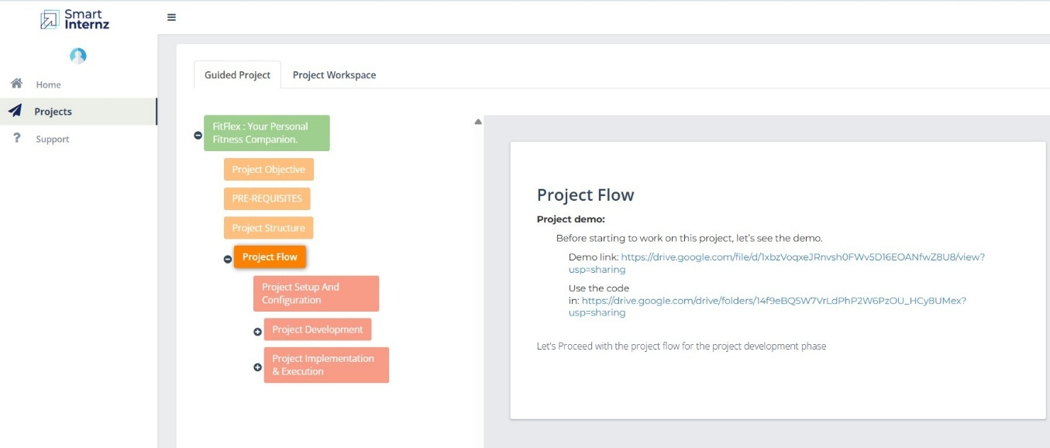

* *Download the the code folder*

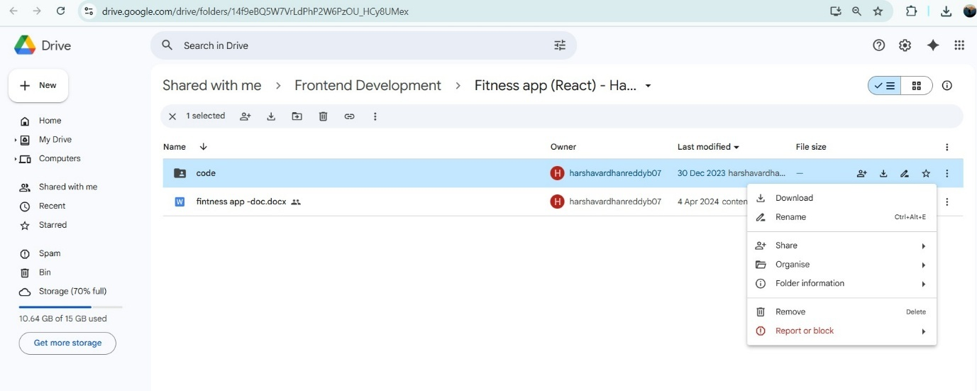

* *Now go to downloads and* ***right click*** *on the downloaded zip folder and click on* ***extract all***

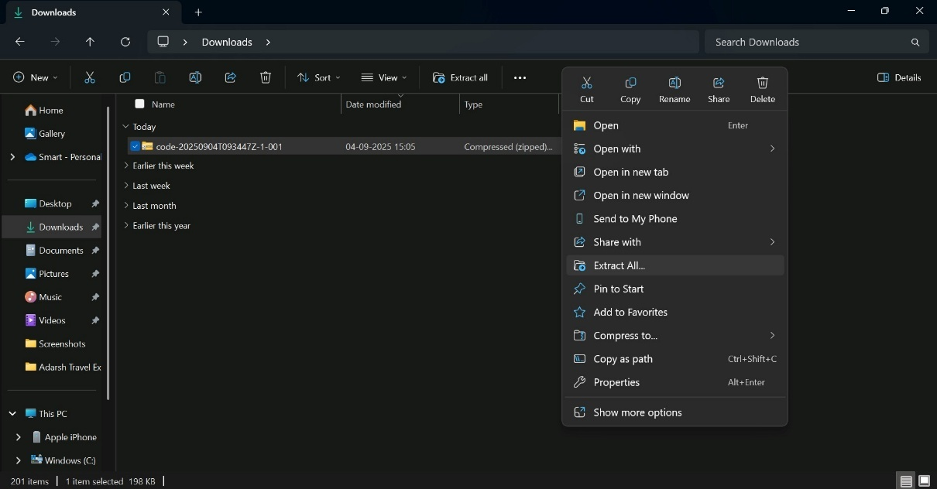

* *Now click on* ***Extract***

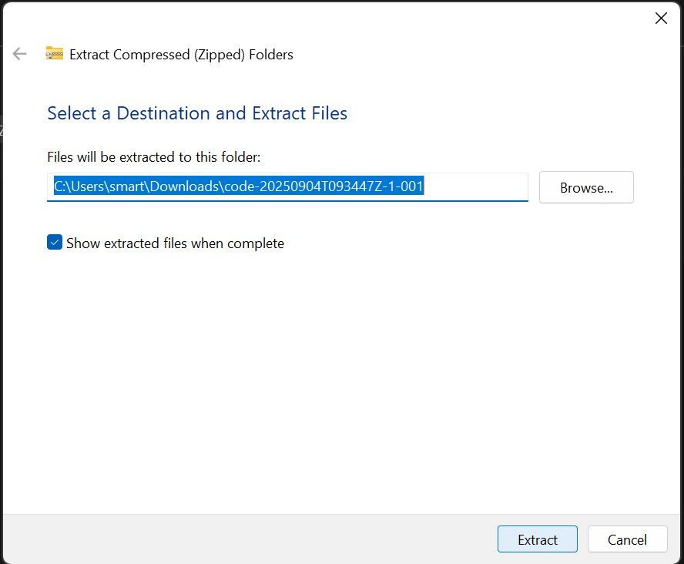

* *Now open VS code and open the* ***code*** *folder from the* ***extracted folder****.*

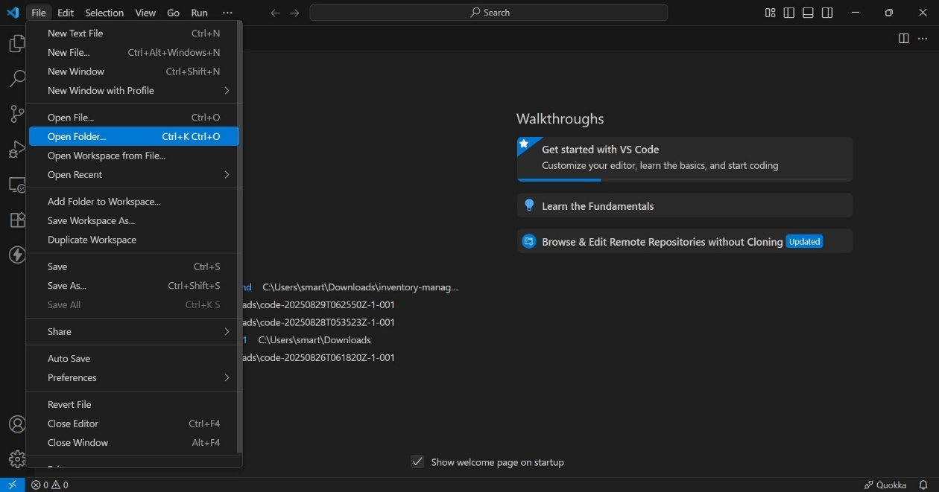

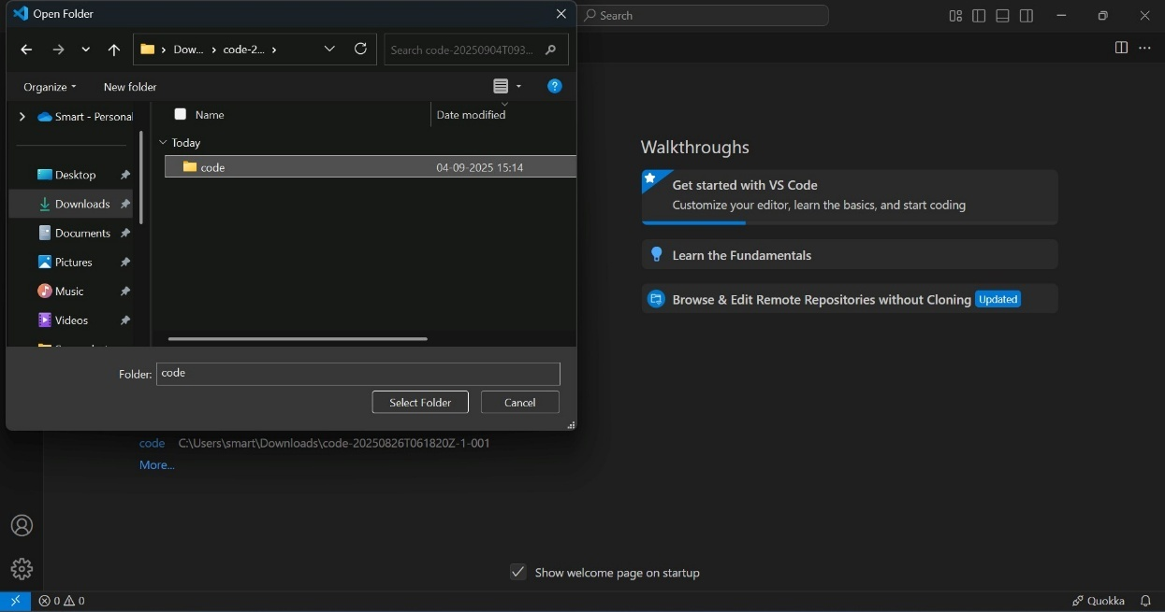

* *Now open a new terminal.*

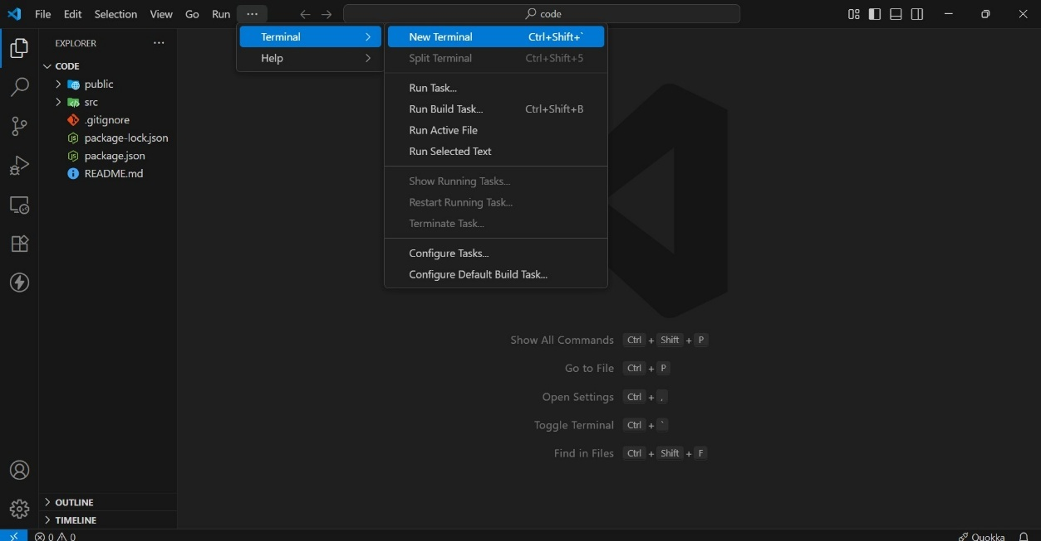

* *Type* ***npm install*** *in your terminal and press* ***Enter*** *and wait till all the dependencies gets download*

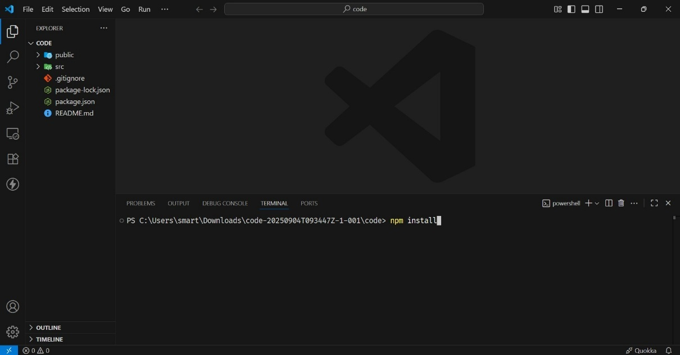

* *After all the downloads finishes, now type* ***npm start*** *and press* ***Enter***

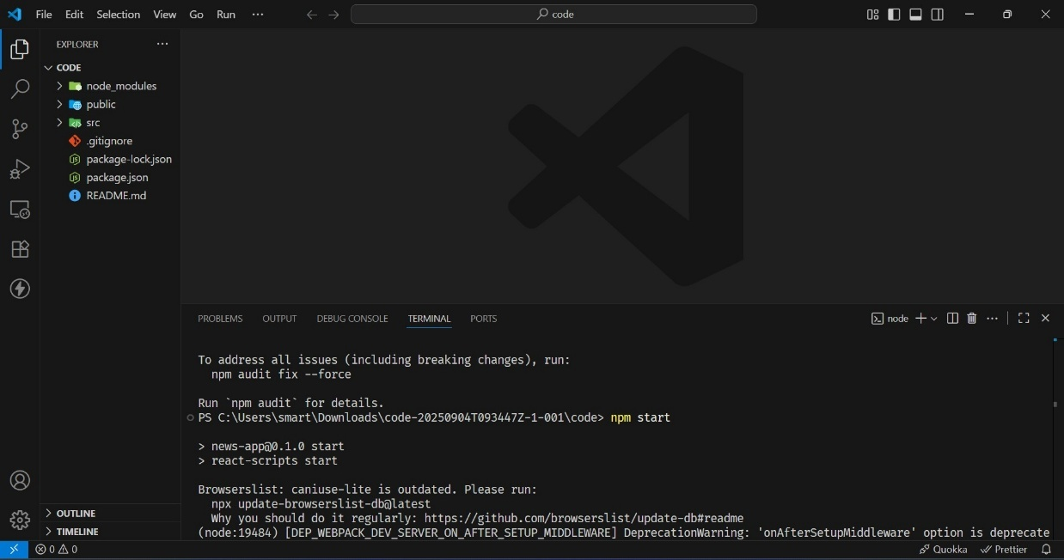

* *Now your application will be opened in your browser with url http://localhost:3000*